Test Case: tc006_SPX_Dev5_Crear_Requisicion_Spot_Tipo_Cobro_Proyect_Urgent
Step 1 - Enter username and password and click to button Enter: Credentials Entered
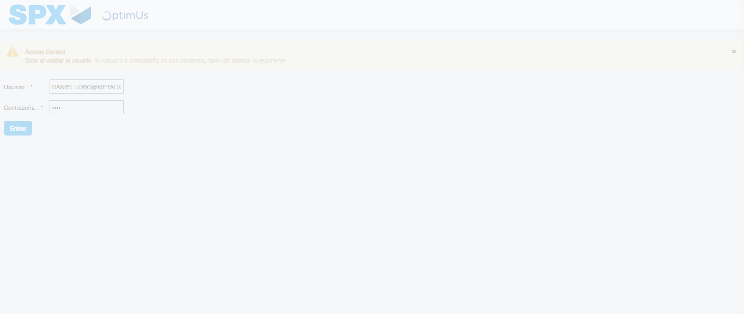Image file-name: QC_Testing-tc006_SPX_Dev5_Crear_Requisicion_Spot_Tipo_Cobro_Proyect_Urgent-1784214900998

Step 2 - Select to UEN and Access to Spot Buy Requisitions : UEN Correctly selected and Correct access
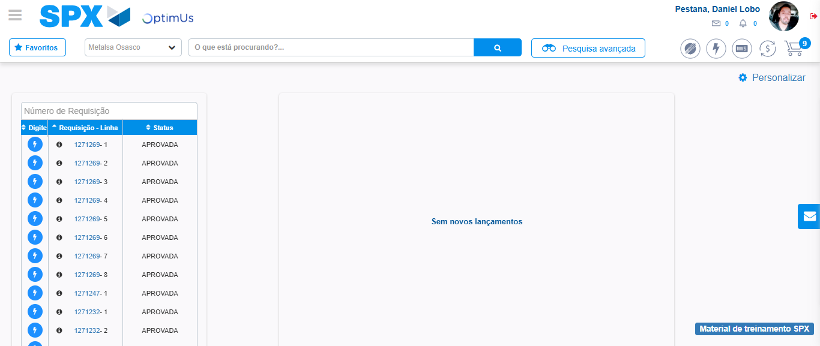Image file-name: QC_Testing-tc006_SPX_Dev5_Crear_Requisicion_Spot_Tipo_Cobro_Proyect_Urgent-1784214926537

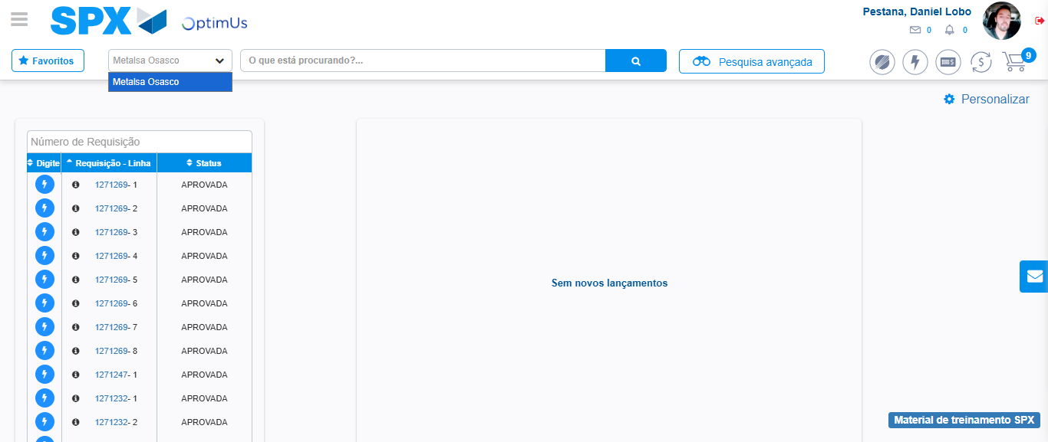Image file-name: QC_Testing-tc006_SPX_Dev5_Crear_Requisicion_Spot_Tipo_Cobro_Proyect_Urgent-1784214929141

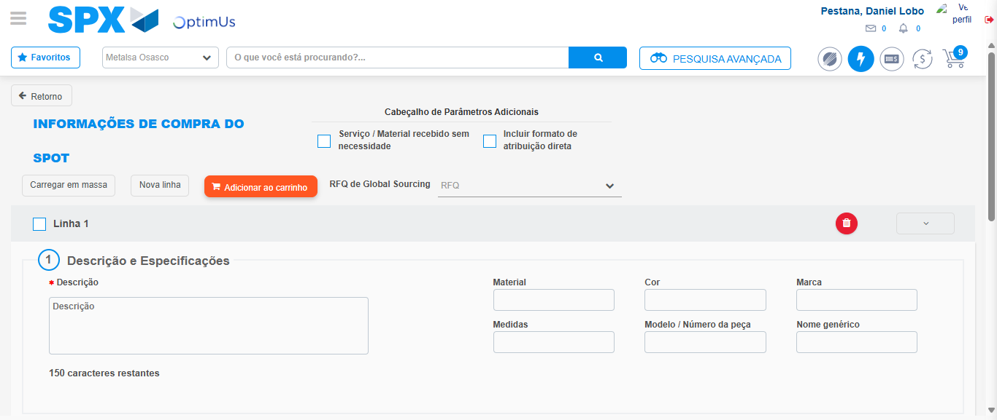Image file-name: QC_Testing-tc006_SPX_Dev5_Crear_Requisicion_Spot_Tipo_Cobro_Proyect_Urgent-1784214947842

Step 3 - Data Capture Spot Buy Requisition: Data captured correctly
Image file-name: QC_Testing-tc006_SPX_Dev5_Crear_Requisicion_Spot_Tipo_Cobro_Proyect_Urgent-1784214948154

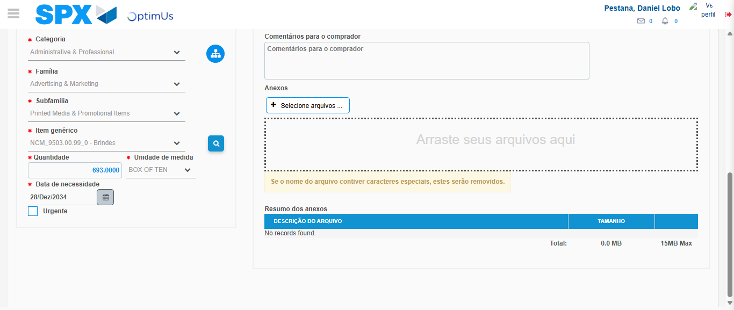Image file-name: QC_Testing-tc006_SPX_Dev5_Crear_Requisicion_Spot_Tipo_Cobro_Proyect_Urgent-1784214961790

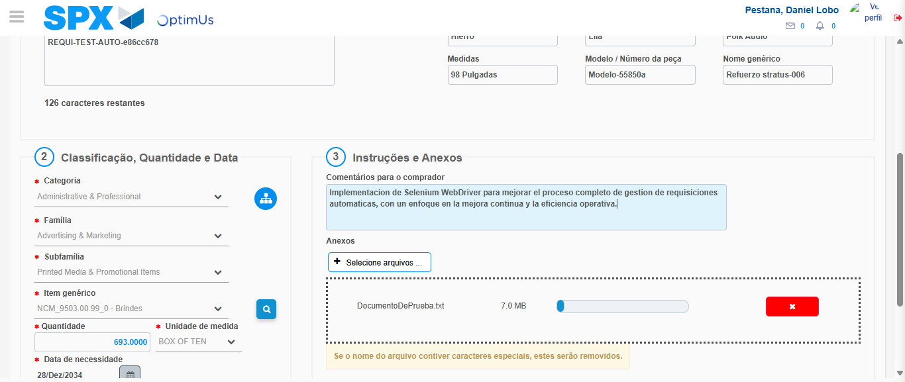Image file-name: QC_Testing-tc006_SPX_Dev5_Crear_Requisicion_Spot_Tipo_Cobro_Proyect_Urgent-1784214962822

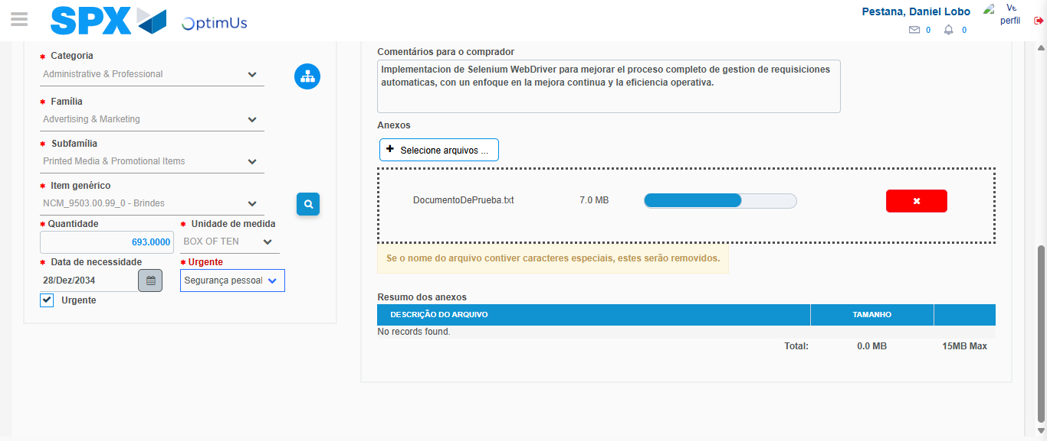Image file-name: QC_Testing-tc006_SPX_Dev5_Crear_Requisicion_Spot_Tipo_Cobro_Proyect_Urgent-1784214967215

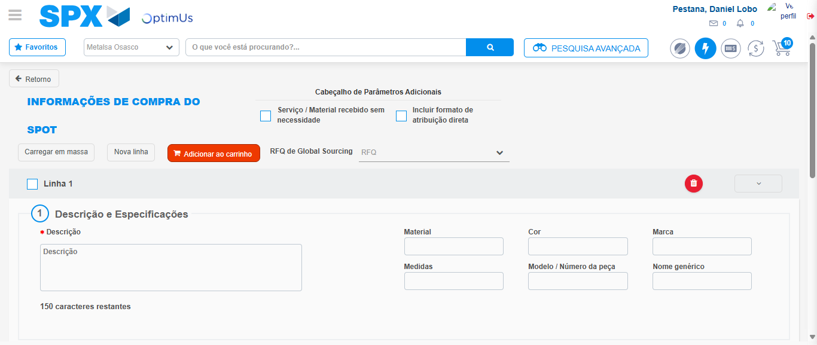Image file-name: QC_Testing-tc006_SPX_Dev5_Crear_Requisicion_Spot_Tipo_Cobro_Proyect_Urgent-1784214972417

Step 7 - Return to Main Page SPX : Return to Main Page SPX
Image file-name: QC_Testing-tc006_SPX_Dev5_Crear_Requisicion_Spot_Tipo_Cobro_Proyect_Urgent-1784214926537

Image file-name: QC_Testing-tc006_SPX_Dev5_Crear_Requisicion_Spot_Tipo_Cobro_Proyect_Urgent-1784214929141

Image file-name: QC_Testing-tc006_SPX_Dev5_Crear_Requisicion_Spot_Tipo_Cobro_Proyect_Urgent-1784214947842

Image file-name: QC_Testing-tc006_SPX_Dev5_Crear_Requisicion_Spot_Tipo_Cobro_Proyect_Urgent-1784214974705

Image file-name: QC_Testing-tc006_SPX_Dev5_Crear_Requisicion_Spot_Tipo_Cobro_Proyect_Urgent-1784214974929

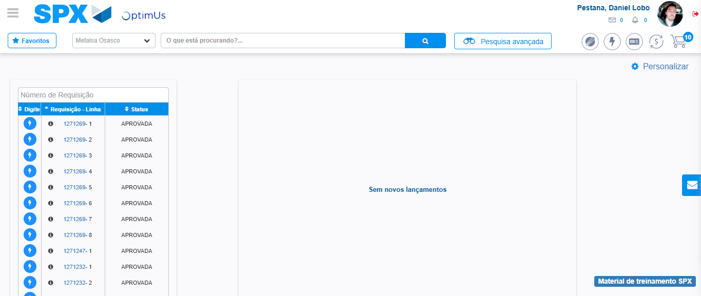Image file-name: QC_Testing-tc006_SPX_Dev5_Crear_Requisicion_Spot_Tipo_Cobro_Proyect_Urgent-1784214996076

Step 8 - Log Out : Log Out SPX
Image file-name: QC_Testing-tc006_SPX_Dev5_Crear_Requisicion_Spot_Tipo_Cobro_Proyect_Urgent-1784214996338

